How to Easily Replace <Your Company Name> with your Actual Company Name

- Open the document in Microsoft Word
- Highlight the phrase <YOUR COMPANY NAME>
- Click on the Find Icon on the upper right
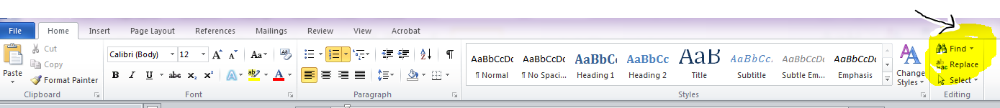
- <YOUR COMPANY NAME> will come up in the navigation box on the left
- Click on the Replace Icon on the upper right
- A box will pop up called Find and Replace. Find what: will be filled in with <YOUR PRACTICE NAME>. Fill in Replace with: with your actual practice name.
- Click Replace all
